Name_____________________________________________________ | 
 Activity 1.1.1 Environmental Problems (Go Direct™)

Purpose
Clean water is necessary for healthy ecosystems. You may or may not consider rain an environmental problem, but moisture can harm organisms and ecosystems when pollutants alter water's physical or chemical properties.

The pH scale indicates the acidity or alkalinity of a substance. Rain is naturally slightly acidic with a typical pH range of 5 to 6 and does not generally cause any problems. As rainwater becomes acidified, the pH decreases. When pollutants mix with water in the atmosphere, the acidity will increase, and the pH will drop. High concentrations of gases released by the by-products of combustion can reduce the pH further to 4.  The effects of environmental problems do not follow county, state, or national boundaries. Activity in your area may cause a crisis somewhere else. A local ecological problem may originate elsewhere. Increasing carbon dioxide, sulfur dioxide, and nitrogen dioxide concentrations in the atmosphere are good examples of global problems with localized effects. These gases can affect soils and marine life when dissolved in water. Since all humans depend on soil and water for food, the problem is local and global. | 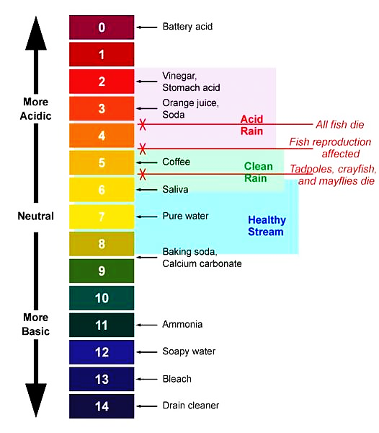  Image from www.osc.edu/ywsi_project_ohios_watersheds/chem/ph
 | Figure 1. Precipitation pH Scale

Human activities, such as burning fossil fuels, contribute carbon dioxide (CO₂)and other gases into the atmosphere. The concentration of carbon dioxide in the atmosphere has increased steadily from 315 parts per million (ppm) in 1960 to 400ppm in 2015. As CO₂ drifts through the atmosphere, it mixes with water, forming carbonic acid. Other combustion gases, including sulfur dioxide and nitric oxide, also form acids in water. Acid rain, acid runoff, and ocean acidification are products of this process.

Acid rain can cause long-term environmental problems, even long after rain returns to normal pH levels. Acidified water percolating through acidic soils often removes nutrients, reducing soil fertility. Nutrients leached from the soil into aquatic systems can be toxic to aquatic life.

Acid rain does not always reduce fertility right away. Alkaline soils act as buffers that neutralize acid rain. Over time, the buffering capacity of the soil decreases.

Figures 2 and 3 show the pH of rainwater across the United States in 2000, then again in 2020. Most acidic rain occurs over and downwind of heavily populated and industrialized areas, especially the northeastern U.S.  Measuring the electrical conductivity of water indicates the concentration of dissolved chemicals in the water. Dissolving chemicals in water increases the conductivity. As acid rainwater removes nutrients from the soil, the concentration of dissolved chemicals in runoff increases, and the runoff water conductivity increases.  How does CO₂ in the air affect the acidity of water? How does acid rain impact soil and water?  Materials  Per student:  - CASE Safety Manual  - Personal protective equipment (PPE)  - Pencil  Per pair of students:  - 100ml pH buffer solution  - (4) 100ml beakers  - (3) 250ml beakers  - 100ml graduated cylinder | 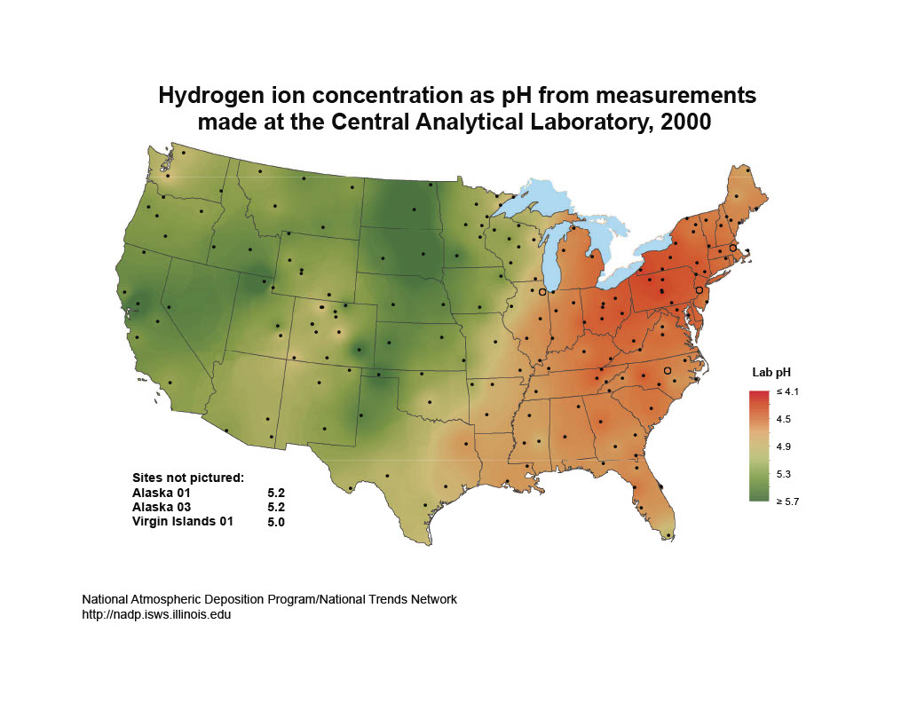
 | Figure 2. Rainwater Acidity in the United States, 2000
 | 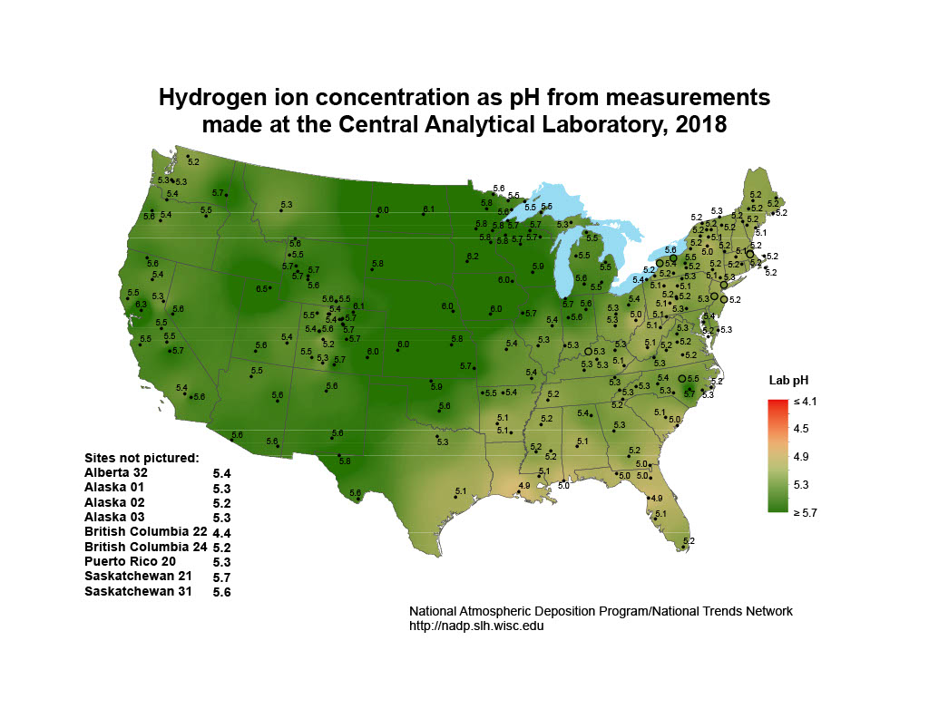
 | Figure 3. Rainwater Acidity in the United States, 2020
- Distilled water (dH₂O)  - Device w/ Graphical Analysis app  - Go Direct™ pH sensor  - Go Direct™ conductivity sensor  - Rinse bottle  - Alcohol burner with ethanol  - Butane lighter  - Large beaker tongs | - ½ gallon wide-mouth mason jar with lid  - Permanent marker  - Laboratory tape  - Small funnel  - (2) coffee filters  - Local soil  - Plastic spoon

Procedure
Work with a partner to imitate the formation of acid rain and observe how it affects your local soil. Work efficiently as the pH may change over time. Review the CASE Safety Manual and use PPE appropriately.

Part One – Producing Acidified Water
- Use the graduated cylinder to measure 100ml of dH₂O.
- Remove the lid from the ½ gallon wide-mouth mason jar.
- Place the alcohol burner safely away from your other lab materials and light it with the butane lighter.
- Invert the mason jar over the burner. Use the beaker tongs to hold the jar. Keep the jar opening below the flame, as shown in Figure 4.
- Hold the jar in place until the flame goes out. Keeping the jar inverted, move it away from the burner.
- With the jar still inverted, place the lid on the jar and twist tight. Place the jar upright on the tabletop.
- Lift the lid slightly and pour 100ml of dH₂O from the graduated cylinder into the jar. Reseal the jar.
- Shake the jar vigorously for 30 seconds. Set the jar on the table and keep it sealed.

Part Two – Measuring Acidity of Water
- Use the marking pen and laboratory tape to label three 250ml beakers as follows.
- dH2O
- Soaking Solution
- Rinse
- Use the marking pen and laboratory tape to label four 100ml beakers as follows.
- dH₂O
- Acid rain
- Runoff from dH₂O
- Runoff from acid rain
- Use a graduated cylinder to measure 100ml of dH₂O and pour it into the 250ml dH₂O beaker.
- Use a graduated cylinder to measure 100ml of pH soaking solution and pour into the Soaking Solution beaker.
- Set up the Graphical Analysis™ app, pH sensor, and temperature sensor.
- Open the Graphical Analysis™ app and turn on the sensors.
- Choose Sensor Setup and select the device numbers representing your sensors by selecting Connect and Done.
- Select View Options and then choose Meter.
- Remove the pH sensor from the storage vial and place it in the pH soaking solution beaker.
- Remove the cap from the conductivity sensor and place the sensor in the beaker with dH2O.
- Pour 100ml dH₂O into the 100ml beaker labeled dH₂O.
- Remove the pH sensor from the soaking solution and rinse the end with dH₂O using the rinse bottle over the rinse beaker.
- Place the pH sensor in the 100ml dH₂O beaker and wait 30 seconds for the reading to stabilize.
- Record the pH in the Distilled Water row of Table 1 on the student data page.
- Rinse the pH sensor with the rinse bottle over the rinse beaker and return to the soaking solution.
- Remove the conductivity sensor from the 250ml dH₂O beaker.
- Place the conductivity sensor in the 100ml dH₂O beaker and wait 30 seconds for the reading to stabilize.
- Record the conductivity in the Distilled Water row of Table 1.
- Rinse the sensor with the rinse bottle and return the sensor to the 250ml dH₂O beaker.
- Working quickly, remove the cap from the jar and pour the acidified water into the Acid Rain 100ml beaker.
- Repeat Steps 7–14 for the acidified water. Record results in the Acidified Water row of Table 1.
- While one partner collects data for the acidified water, the other partner should set up Steps 1–2 of Part Three.

Part Three –Soil Runoff
- Place a coffee filter in the funnel and add four heaping spoonfuls of soil to the funnel.
- Set the funnel on the 100ml beaker labeled Runoff from Acidified Water.
- Pour 100ml of acidified water through the soil in the funnel and collect the runoff in the beaker.
- If less than 50ml of runoff collects in the beaker, slowly add distilled water through the funnel until the beaker contains 50ml of runoff.
- Repeat Steps 7–14 of Part Two for the runoff from acidified water. Record results in Table 1.
- Dispose of the used soil and coffee filter as instructed.
- Rinse the funnel with water.
- Repeat Steps 1–6 of Part Three replacing acidified water with dH₂O.
- Rinse the sensors with dH₂O over the rinse beakers and store the sensors.
- Dispose of the solutions as instructed.
- Answer the analysis questions on the student data page.

Conclusion
- How does acidified rain affect soil when compared to distilled water?

- How can a distant pollution source affect your local soil and water?

- What problem(s) does acid rain pose for the environment?

- Why is it important to understand environmental problems, such as acid rain, to solve them?

Name_____________________________________________________
Activity 1.1.1 Student Data

Table 1. pH and Conductivity Data
Control Test | pH | Conductivity (µS)
dH₂O
Runoff from dH₂O
Change in dH₂O
Variable Test | pH | Conductivity (µS)
Acidified Water
Runoff from Acidified Water
Change in Acidified Water

Analysis
- Describe the pH differences between distilled water and acidified water. What process is producing this change?

- Discuss the pH change in runoff from distilled water and acidified water. How did soil filtration affect acidity?

- Describe the conductivity changes that occur when the acidified water percolates through the soil and becomes runoff. What is happening to the soil nutrients? What is happening to soil fertility?

- Describe any other changes in pH or conductivity you observe.

