Name_____________________________________________________ | 
 Activity 1.1.3 Shared Problems

Purpose
You studied how an environmental problem, such as acid rain, affects a local area. Imagine the loss of soil nutrients occurring daily on a global scale. Problems created at local, national, and global levels pose unique effects and create additional challenges for the environment and human activity.

The warming of the Earth's atmosphere is an example of global climate change. The Earth's overall temperature balances the solar energy the Earth absorbs and the energy that escapes into space. Earth receives light energy from the sun. The Earth's surface absorbs the light and converts it into heat energy. Radiated heat can escape back into space or warm the Earth's lower atmosphere.  Several atmospheric gases trap heat in the troposphere, the lowest level of the atmosphere, raising the temperature. The gases include water vapor, nitrous oxide, methane, and CO₂. As the concentrations of these gases increase, they trap heat energy. The trapped heat causes the temperature of the troposphere to increase and change the Earth's climate.  For the past 200 years, concentrations of CO₂ in the atmosphere have been increasing steadily. This increase results from burning more significant amounts of coal, oil, and other fossil fuels. Higher concentrations of carbon dioxide trap heat, raising the Earth's temperature. | 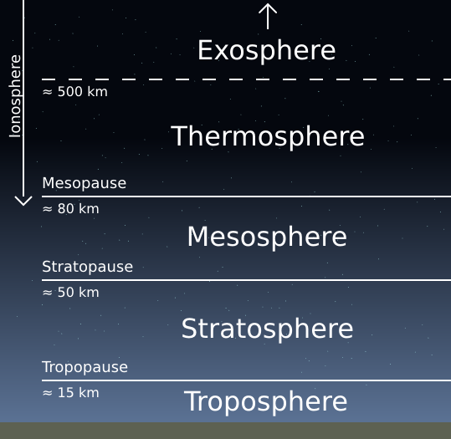  Image from https://content.meteoblue.com/en/meteoscool/the-earth/atmosphere
 | Figure 1. Atmospheric Layers

The rising temperature of the Earth has different effects around the world. Extreme weather, environmental problems, and effects on human activity, all related to climate change, vary from one location to another.

How has the average temperature changed in regions around the world? How do extreme weather events and environmental problems caused by climate change impact people around the globe?

Materials
Per student:  - Device with internet access  - Pen | - ESI Notebook  - Laboratory Notebook

Procedure
Your team of three will research temperatures throughout recent history, then identify extreme weather events and problems associated with climate change. One team member will research local information, another team member will research national information, and the third team member will find global information. Assign each team member to Part One, Part Two, or Part Three. Then summarize your research within your team and determine the impact of climate change on human populations.

Part One – Local Climate Changes and Problems
- Write the name of your state in your Laboratory Notebook.
- Use the internet to answer the following questions about climate change in your state. Record answers in your Laboratory Notebook. Your teacher may suggest a few websites if the information is challenging to locate.
- How has the average temperature changed in the state over the past 100 years?
- Which types of extreme weather are occurring in the state?
- What are two problems in the state caused by climate change?
- How will climate change in the state affect people?
- Meet with your teammates and move on to Part Four.

Part Two – National Climate Changes and Problems
- Use the internet to answer the following questions about climate change in the United States. Your teacher may suggest a few websites if the information is challenging to locate. Record answers in your Laboratory Notebook.
- How has the average temperature changed in the country over the past 100 years?
- Which types of extreme weather are occurring in the country?
- What are two problems in the country caused by climate change?
- How will climate change in the country affect people?
- Meet with your teammates and move on to Part Four.

Part Three – Global Climate Changes and Problems
- Use the internet to answer the following questions about global climate change. Record answers in your Laboratory Notebook. Your teacher may suggest a few websites if the information is challenging to locate.
- How has the average temperature changed in the world over the past 100 years?
- Identify extreme events related to global climate change.
- What are two global problems climate change will cause?
- What are two ways global climate change will affect people?
- Meet with your teammates and move on to Part Four.

Part Four – Sharing Results
In your team, compare findings for your state, country, and the world. Discuss state, national, and global temperatures, extreme events, and environmental problems. Then discuss how climate change has impacted human populations. Record your discussion in your Laboratory Notebook.

Conclusion
- What environmental problems does climate change produce?
- What is a local problem resulting from climate change?
- Which local, national, and global problems found are related to climate change?
- How does the impact of climate change on people vary from place to place?

