Name_____________________________________________________ | 
 Activity 1.1.4 What’s the Issue?

Purpose
You studied environmental problems earlier in this lesson. When does an environmental problem become an issue?  Scientists attempt to solve environmental problems based on factual research and data. A fact is a measurement or observation proven correct. Your height and the city of your birth are facts. A problem is a situation that has a solution. Your car breaking down is a problem. When there are many solutions to the same problem, disagreements and disputes about the solution occur. These disagreements make a problem an issue. An issue is a matter in dispute or about which people disagree. Cell phones in the classroom are an issue because people disagree on what rules are appropriate.  Figure 1 shows a flowchart with simple questions to determine whether a statement is a fact, a problem, or an issue.  What are the facts, problems, and issues found in environmental science? | 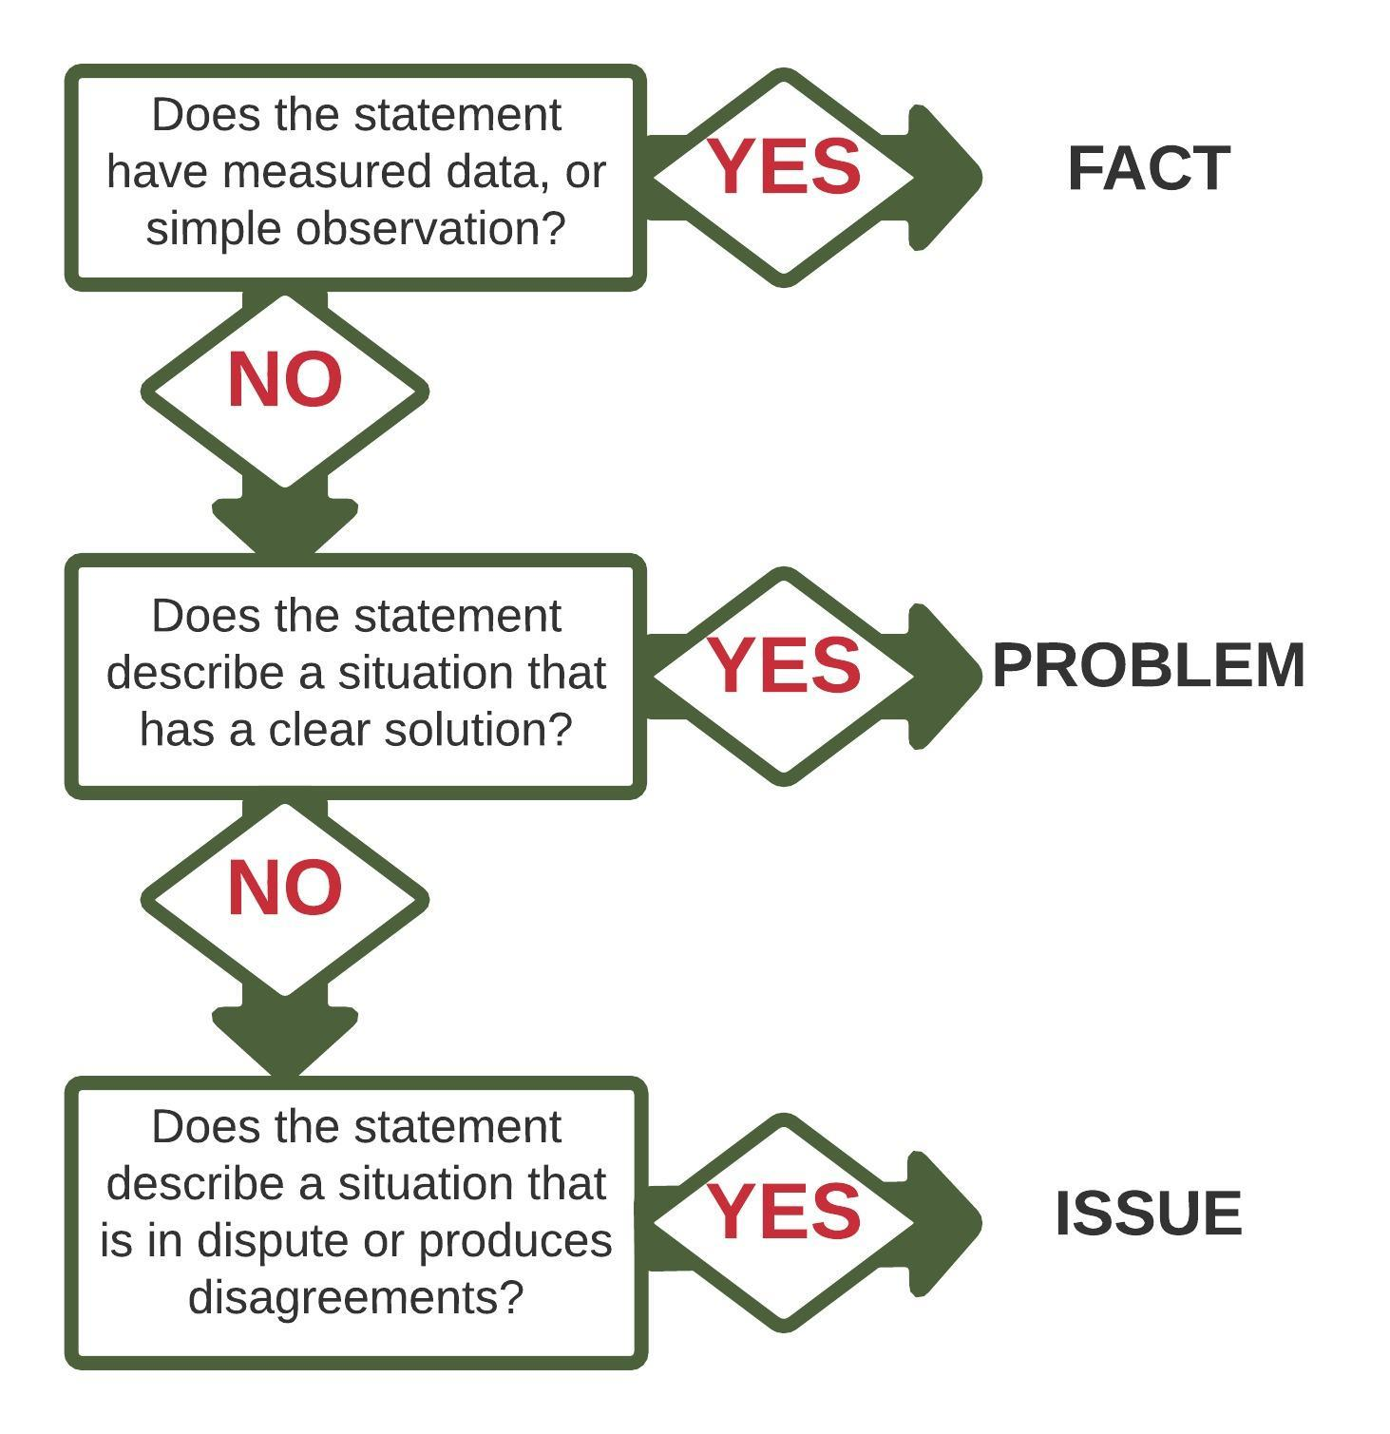
 | Figure 1. Fact-Problem-Issue Flowchart

Materials
Per group of four students:  - (6) sticky notes  - Device with internet access  Per class:  - (3) poster boards  - Assorted markers | Per student:  - Pen  - ESI Notebook  - Laboratory Notebook

Procedure
Categorize statements as facts, problems, or issues. Then research a topic in environmental science and find a fact, problem, and issue within that topic.

Part One – Define Issues, Problems, and Facts
- Use the flowchart in Figure 1 to identify the following statements as a fact, problem, or issue. Record the statements in your Laboratory Notebook and label them as a fact, problem, or issue.
- The stream temperature is 76°F.
- The stream banks do not have enough shade trees to cool the water.
- To preserve water quality, logging should not be allowed in the watershed.
- Review your answers with your teacher.
- In your Laboratory Notebook, make a table with three columns titled Facts, Problems, and Issues.
- Practice identifying statements using the following list. Use the flowchart in Figure 1 to identify the statements as facts, problems, or issues, then record them in the correct column in your table.
- There are 1,000 chickens in this barn.
- It is acceptable to raise chickens in the smallest space possible.
- The water level in my groundwater well has been dropping for years.
- State leaders should divert groundwater from agricultural use to industrial use.
- The water level in my groundwater well is at 202 ft.
- Producers have found the avian influenza virus in the barn.
- Cleaning polluted water is not worth the cost.
- The sewage plant leaks.
- The D.O. concentration is 8mg/l.
- Once you have finished, review your results with your partner.

Part Two – Identify Environmental Facts, Problems, and Issues.
- With your partner, select an environmental topic from below or another topic approved by your teacher.
- Biodiversity | - Genetic engineering | - Renewable energy
- Carbon footprint | - Habitat destruction | - Soil degradation
- Climate change | - Logging | - Water pollution
- Food safety | - Mining | - Wildlife depletion
- Fracking | - Overpopulation
- Use the internet to research your topic. Identify two facts, two problems, and two issues for your topic.
- Write each fact, problem, and issue on a separate sticky note. You should have six notes. Do not label the statements as facts, problems, or issues.
- Shuffle your notes and exchange them with another pair of students.
- Sort the other students’ notes into the categories of facts, problems, and issues.
- Discuss your groupings with the other pair of students. Verify and compare your groupings.
- Repeat Steps 4–6 with a different pair of students, then retrieve your original set of statements.
- Label each of your statements as facts, problems, or issues based upon your discussions.

Part Three – Class Environmental Issues
- Locate the Facts, Problems, and Issues posters. Place your six notes on the appropriate posters.
- Your teacher will review the notes on the Issues poster.
- Record the class list of issues in your Laboratory Notebook.

Conclusion
- List one example of a fact, a problem, and an issue from your everyday life.
- What makes an issue different from a problem?
- Why are environmental issues difficult to solve?

