Name ____________________________________________________________ | 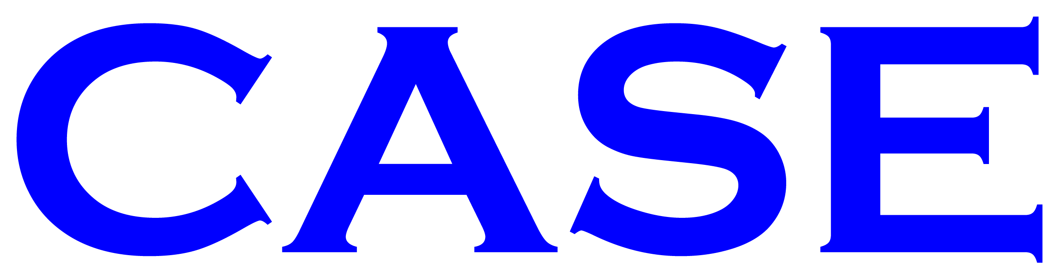
FFA Activity Log

FFA Leadership Activities
Activity | Indicate year completed under the appropriate level
FFA offices held and related FFA activities | Chapter | Area, District, or Regional | State | National Finals/Multi-State Event | National

Non-Leadership FFA Activities
Activity | Indicate year completed under the appropriate level
Includes Career Development Events and Service Activities | Chapter | Area, District, or Regional | State | National Finals/Multi-State Event | National

School and Community Activities
Activity | Year

Awards and Recognitions
Award and Recognition Title | Year

